Github Link: https://github.com/HaydenDuong/SIT305-Mobile_Application_Development/tree/main/Task%204.1P

Demo Link: https://deakin.au.panopto.com/Panopto/Pages/Viewer.aspx?id=76fd72de-5396-4971-a6c3-b2c400854fcf

Pictures

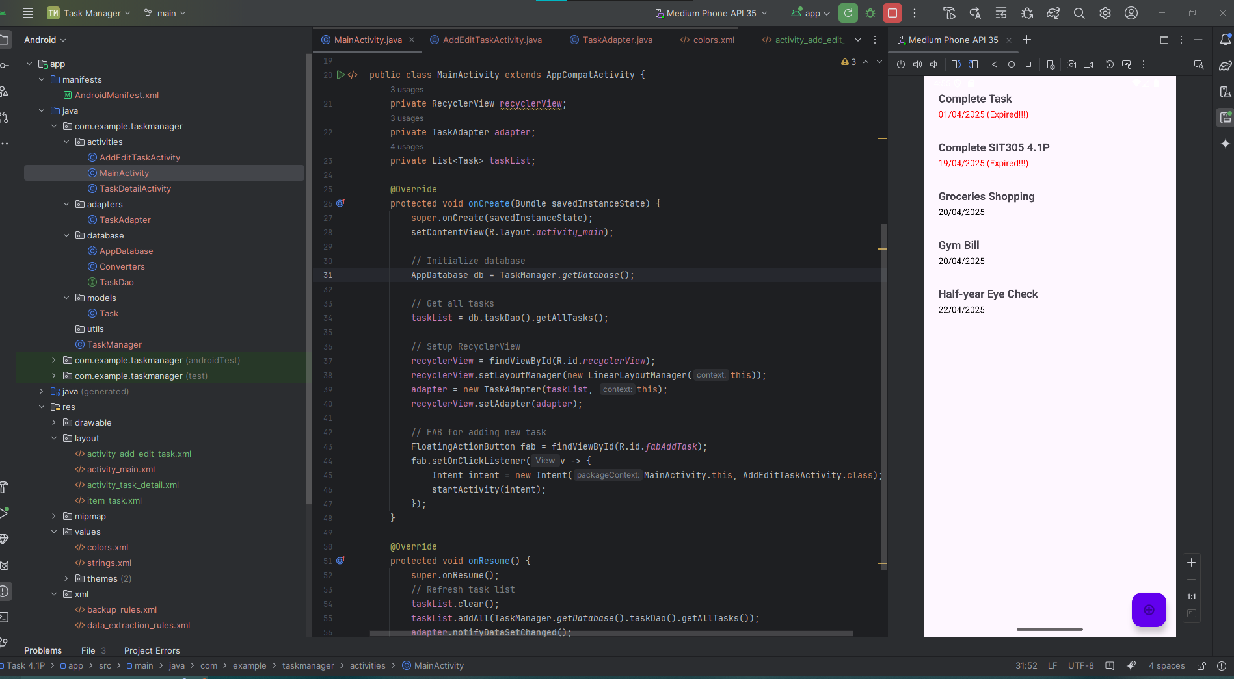

MainActivity – used for displaying all the stored tasks (including both ongoing and expired tasks – which is marked by red color text) & a float button for adding a new task.

TaskDetailActivity – Enter by selecting a displayed task, it displays the description of a task and with three following option buttons: “Edit Task”, “Delete Task”, and “Return To Home”

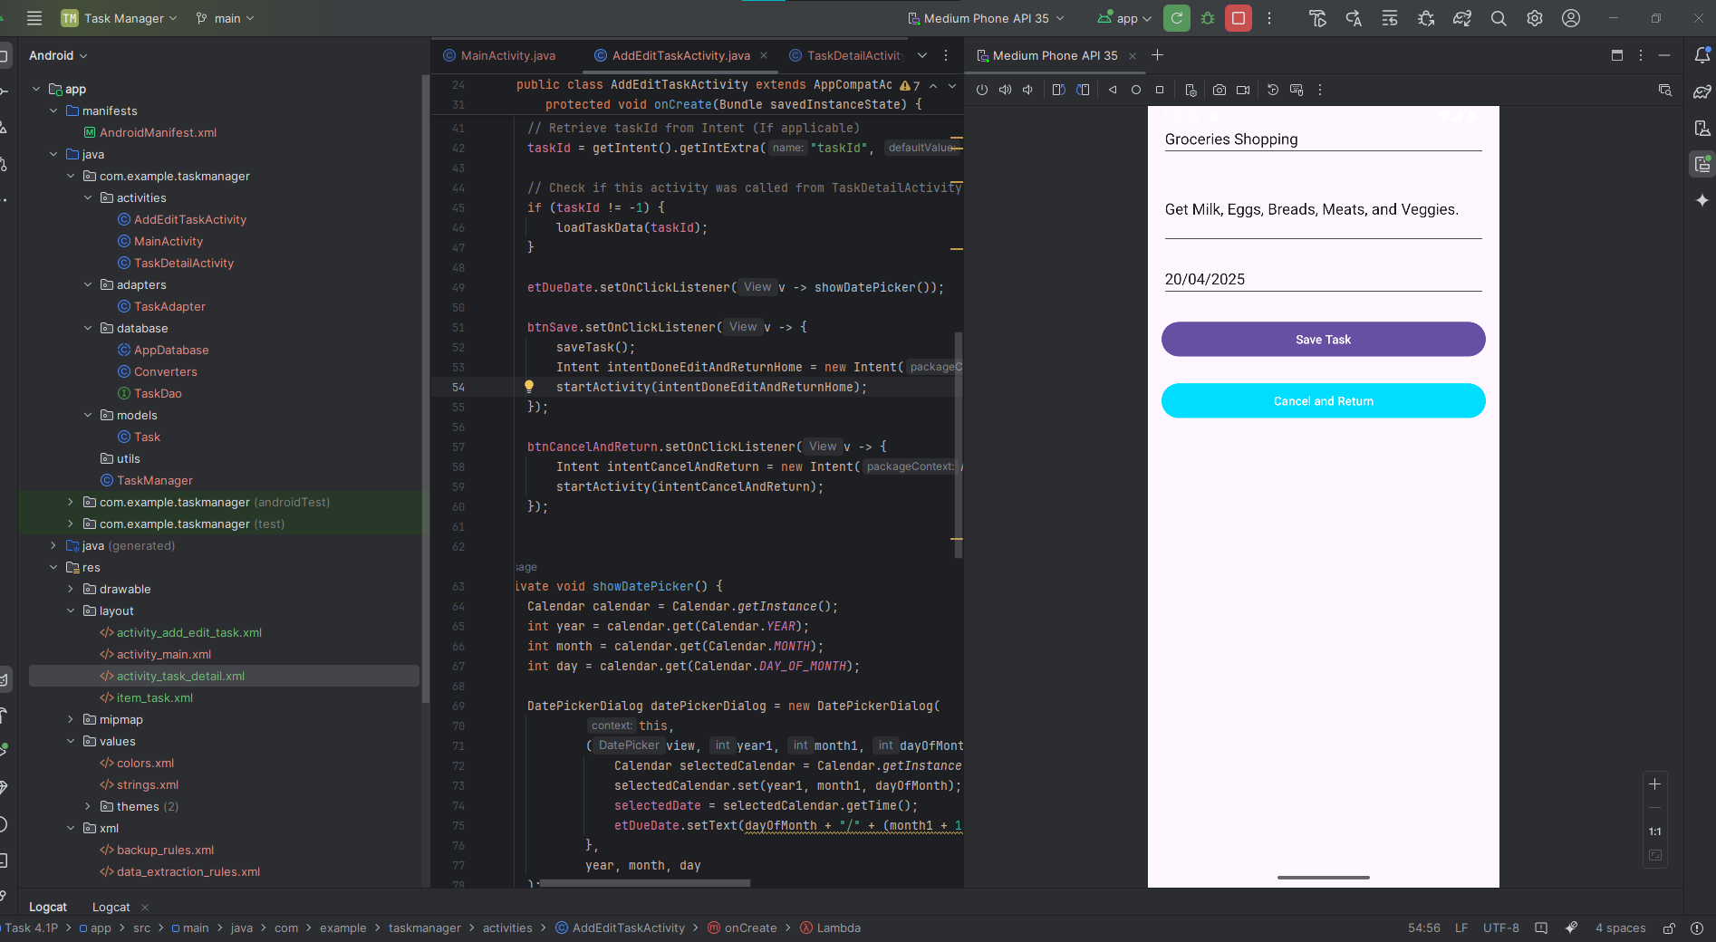

AddEditTaskActivity – Enter through: clicked the floating purple button in the MainActivity; or by clicked “Edit Task” in TaskDetailActivity which information of the current task will be displayed for user to edit and save it afterward. User can also click “Cancel and Return” to return back to the MainActivity – since AddEditTaskActivity is being shared between edit a curren existing task and create a new task thus. Click “Delete Task” will remove this task from the main screen in MainActivity.